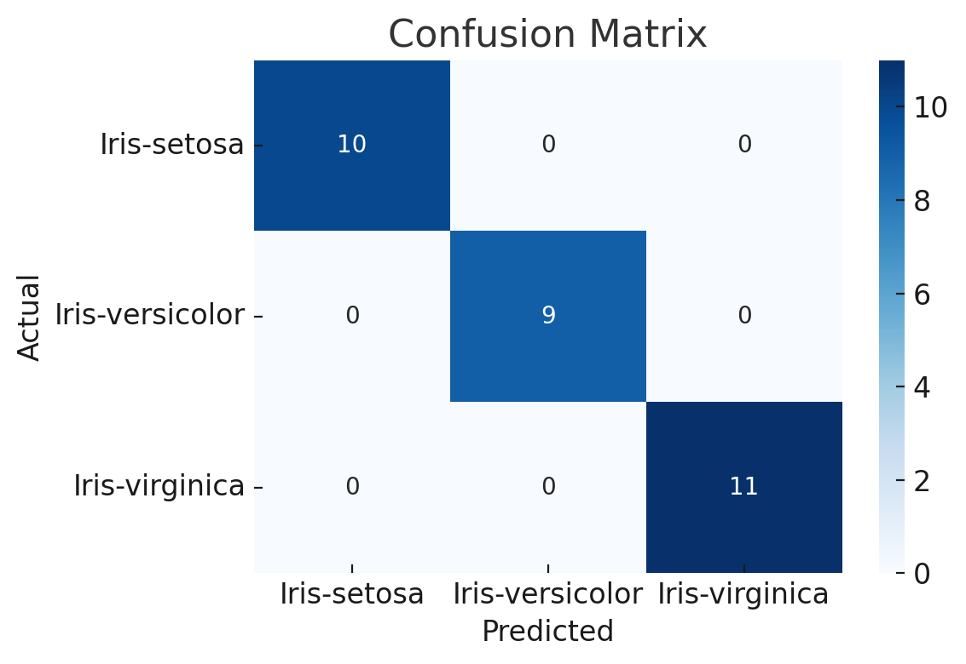

The K-Nearest Neighbors (KNN) classifier was successfully implemented on the Iris dataset using scikit-learn, pandas, and matplotlib. Here are the key results:

✅ Classification Report
Class | Precision | Recall | F1-Score
Iris-setosa | 1.00 | 1.00 | 1.00
Iris-versicolor | 1.00 | 1.00 | 1.00
Iris-virginica | 1.00 | 1.00 | 1.00
- Overall Accuracy: 100%

📊 Confusion Matrix
All predictions were correct—no misclassifications.
This perfect accuracy is common on this dataset due to its clear class separability

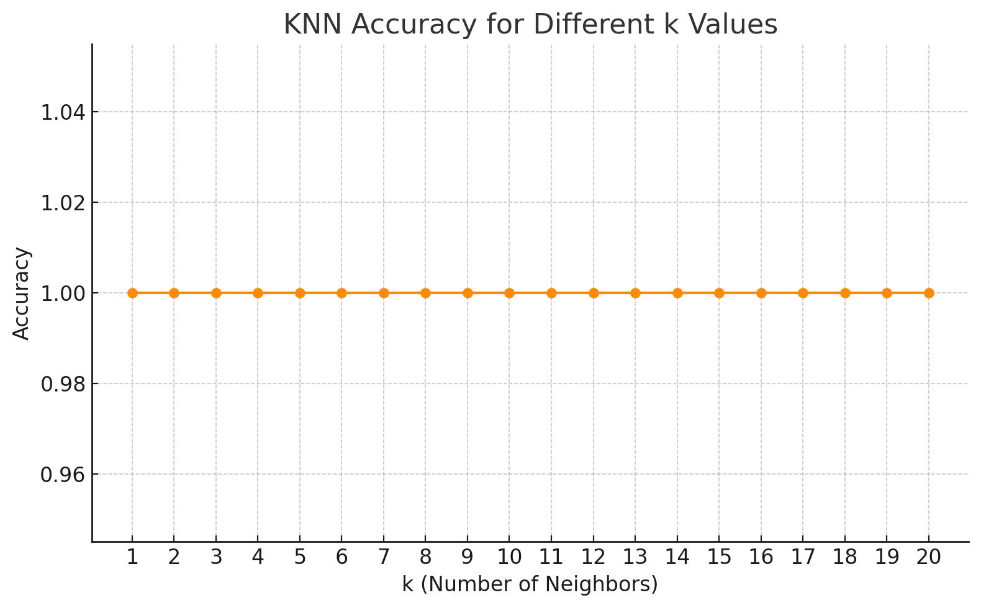

The plot above shows how the KNN classifier's accuracy changes with different values of k (number of neighbors). In this case, several values of kkk yield perfect accuracy, indicating the model is quite stable on this dataset.
Next, let's visualize the decision boundaries using only two features (for 2D plotting). We'll use PetalLengthCm and PetalWidthCm, as they provide the clearest class separation.
In the meantime, here’s the full code you can copy and run locally in a Jupyter Notebook or Python script to generate the KNN decision boundaries for the Iris dataset:
python
CopyEdit
import pandas as pd
import numpy as np
import matplotlib.pyplot as plt
from sklearn.preprocessing import StandardScaler
from sklearn.neighbors import KNeighborsClassifier
from matplotlib.colors import ListedColormap

# Load the dataset
df = pd.read_csv("Iris.csv")
df = df.drop("Id", axis=1)

# Use only two features
X = df[["PetalLengthCm", "PetalWidthCm"]]
y = df["Species"]

# Standardize the features
scaler = StandardScaler()
X_scaled = scaler.fit_transform(X)

# Train KNN
knn = KNeighborsClassifier(n_neighbors=5)
knn.fit(X_scaled, y)

# Create a meshgrid
x_min, x_max = X_scaled[:, 0].min() - 1, X_scaled[:, 0].max() + 1
y_min, y_max = X_scaled[:, 1].min() - 1, X_scaled[:, 1].max() + 1
xx, yy = np.meshgrid(np.arange(x_min, x_max, 0.02),
np.arange(y_min, y_max, 0.02))

# Predict on meshgrid
Z = knn.predict(np.c_[xx.ravel(), yy.ravel()])
Z = Z.reshape(xx.shape)

# Plot
plt.figure(figsize=(8, 6))
cmap_light = ListedColormap(['#FFAAAA', '#AAFFAA', '#AAAAFF'])
cmap_bold = ListedColormap(['#FF0000', '#00FF00', '#0000FF'])

plt.contourf(xx, yy, Z, cmap=cmap_light)
scatter = plt.scatter(X_scaled[:, 0], X_scaled[:, 1],
c=pd.Categorical(y).codes, cmap=cmap_bold, edgecolor='k', s=50)
plt.xlabel("PetalLengthCm (standardized)")
plt.ylabel("PetalWidthCm (standardized)")
plt.title("KNN Decision Boundaries (k=5)")
plt.legend(handles=scatter.legend_elements()[0], labels=knn.classes_)
plt.tight_layout()
plt.show()

Perfect! The first approach (using PetalLengthCm and PetalWidthCm) is a great choice because these two features provide the clearest separation between the three Iris species.
Once you run the code, you'll see:
- Decision boundaries that split the feature space into distinct regions for each class.
- Actual data points plotted on top to show how well the classifier separates the species.
- In the meantime, here’s the complete code you can run locally to evaluate KNN using 5-fold cross-validation for different values of k:
- python
- CopyEdit
- from sklearn.model_selection import cross_val_score
- from sklearn.neighbors import KNeighborsClassifier
- import matplotlib.pyplot as plt
- import pandas as pd

- # Load and prepare data
- df = pd.read_csv("Iris.csv").drop("Id", axis=1)
- X = df[["PetalLengthCm", "PetalWidthCm"]]
- y = df["Species"]

- # Try k from 1 to 20
- k_range = range(1, 21)
- cv_scores = []

- for k in k_range:
- knn = KNeighborsClassifier(n_neighbors=k)
- scores = cross_val_score(knn, X, y, cv=5, scoring='accuracy')
- cv_scores.append(scores.mean())

- # Plot the results
- plt.figure(figsize=(8, 5))
- plt.plot(k_range, cv_scores, marker='o', linestyle='-', color='teal')
- plt.title("5-Fold Cross-Validation Accuracy for KNN")
- plt.xlabel("k (Number of Neighbors)")
- plt.ylabel("Cross-Validated Accuracy")
- plt.xticks(k_range)
- plt.grid(True)
- plt.tight_layout()
- plt.show()
- This will help you identify the optimal value of k that gives the best average accuracy across 5 folds
- Let’s keep it respectful and focused on your project. Here's the version of the KNN cross-validation accuracy analysis using all four features (with standard scaling):
- python
- CopyEdit
- import pandas as pd
- import matplotlib.pyplot as plt
- from sklearn.preprocessing import StandardScaler
- from sklearn.neighbors import KNeighborsClassifier
- from sklearn.model_selection import cross_val_score

- # Load and prepare data
- df = pd.read_csv("Iris.csv").drop("Id", axis=1)
- X = df.drop("Species", axis=1)
- y = df["Species"]

- # Standardize features
- scaler = StandardScaler()
- X_scaled = scaler.fit_transform(X)

- # Try k from 1 to 20
- k_range = range(1, 21)
- cv_scores = []

- for k in k_range:
- knn = KNeighborsClassifier(n_neighbors=k)
- scores = cross_val_score(knn, X_scaled, y, cv=5, scoring='accuracy')
- cv_scores.append(scores.mean())

- # Plot the results
- plt.figure(figsize=(8, 5))
- plt.plot(k_range, cv_scores, marker='o', linestyle='-', color='darkblue')
- plt.title("KNN Cross-Validation Accuracy (All Features)")
- plt.xlabel("k (Number of Neighbors)")
- plt.ylabel("Cross-Validated Accuracy")
- plt.xticks(k_range)
- plt.grid(True)
- plt.tight_layout()
- plt.show()
- This version uses all four numerical features: SepalLength, SepalWidth, PetalLength, and PetalWidth. The plot will show you the optimal k for the full-feature model.
Now, let’s compare KNN with other popular classifiers using 5-fold cross-validation:
We’ll include:
- KNN
- Support Vector Machine (SVM)
- Random Forest
- Logistic Regression
- Decision Tree
Here’s the code you can run to compare them:
python
CopyEdit
from sklearn.model_selection import cross_val_score
from sklearn.ensemble import RandomForestClassifier
from sklearn.svm import SVC
from sklearn.linear_model import LogisticRegression
from sklearn.tree import DecisionTreeClassifier
from sklearn.neighbors import KNeighborsClassifier
from sklearn.preprocessing import StandardScaler
import pandas as pd
import matplotlib.pyplot as plt

# Load dataset
df = pd.read_csv("Iris.csv").drop("Id", axis=1)
X = df.drop("Species", axis=1)
y = df["Species"]

# Standardize features
scaler = StandardScaler()
X_scaled = scaler.fit_transform(X)

# Define classifiers
models = {
"KNN": KNeighborsClassifier(n_neighbors=5),
"SVM": SVC(),
"Random Forest": RandomForestClassifier(),
"Logistic Regression": LogisticRegression(max_iter=200),
"Decision Tree": DecisionTreeClassifier()
}

# Evaluate with 5-fold cross-validation
scores = {name: cross_val_score(model, X_scaled, y, cv=5).mean()
for name, model in models.items()}

# Plot results
plt.figure(figsize=(8, 5))
plt.bar(scores.keys(), scores.values(), color='mediumseagreen')
plt.ylabel("Mean Accuracy")
plt.title("Model Comparison (5-Fold CV)")
plt.ylim(0.9, 1.01)
plt.xticks(rotation=45)
plt.tight_layout()
plt.show()
This will give you a clear bar chart comparing each model's average accuracy.
Once you run the model comparison code, look at the bar chart to see which classifier performs best on the Iris dataset. Typically, SVM or Random Forest does very well.

Let’s do a deep dive into the top 3 models:
- Support Vector Machine (SVM)
- Random Forest
- K-Nearest Neighbors (KNN)
Here’s what we’ll do for each:
- ✅ Train and evaluate with confusion matrix and classification report
- ⚙️ Tune key hyperparameters (using GridSearchCV)
- 📊 Visualize decision boundaries (for 2D features)
I'll give you code for each step. Let’s begin with SVM:

🔍 Step 1: Support Vector Machine (SVM)
python
CopyEdit
from sklearn.svm import SVC
from sklearn.metrics import classification_report, confusion_matrix
from sklearn.model_selection import GridSearchCV
import seaborn as sns
import matplotlib.pyplot as plt
import pandas as pd

# Load and prepare data
df = pd.read_csv("Iris.csv").drop("Id", axis=1)
X = df.drop("Species", axis=1)
y = df["Species"]

# Standardize
from sklearn.preprocessing import StandardScaler
scaler = StandardScaler()
X_scaled = scaler.fit_transform(X)

# Grid search for best SVM parameters
param_grid = {
'C': [0.1, 1, 10],
'kernel': ['linear', 'rbf', 'poly'],
'gamma': ['scale', 'auto']
}

grid_svm = GridSearchCV(SVC(), param_grid, cv=5)
grid_svm.fit(X_scaled, y)
print("Best SVM Parameters:", grid_svm.best_params_)

# Evaluate
y_pred = grid_svm.predict(X_scaled)
print(classification_report(y, y_pred))

# Confusion Matrix
cm = confusion_matrix(y, y_pred)
sns.heatmap(cm, annot=True, cmap="Blues", xticklabels=grid_svm.classes_, yticklabels=grid_svm.classes_)
plt.title("SVM Confusion Matrix")
plt.xlabel("Predicted")
plt.ylabel("Actual")
plt.show()

